

|  |
| --- |
|  |
| Guest User Training Guide  Scope: Non-Zedra Users Guide for the External Collaboration Platform  Project Manager: Jack Boocock  Author: Irimie Razvan |



Zedra External Collaboration  
Platform

Version: 1.0

Date: 09.28.2020

#### ABOUT THIS DOCUMENT

* 1. **Document control:**

|  |  |  |  |
| --- | --- | --- | --- |
| Version | Date | Changed By | Purpose of revision |
| 1.0 | 09.28.2020 | Razvan Irimie | Created Document |
|  |  |  |  |
|  |  |  |  |

* 1. **About:**

The Zedra External Collaboration Platform is a solution based on **SharePoint Online** which allows users to easily collaborate on documents and content with Zedra Staff. Users can upload, share and manage content and documents using in a familiar and intuitive manner.

* 1. **Objective:**

The objective of this document is:

* To provide appropriate training and guidance for non-Zedra Staff on how to use the **Zedra** **External** **Collaboration** Platform.

#### ACCESS

1. An **Invitation** will be sent to the email address you provided to the person of contact within Zedra. Access the **External** **Collaboration** platform by clicking the **Open** link.

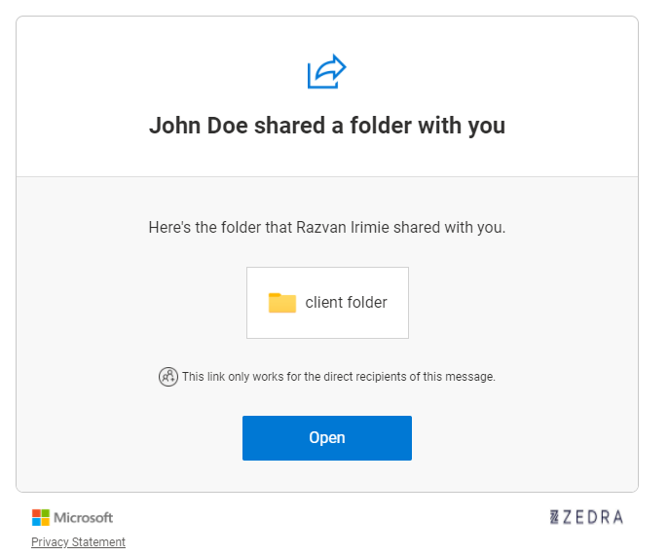

1. Click on the **“Send Code”** and you will receive an **authentication** code via **email**

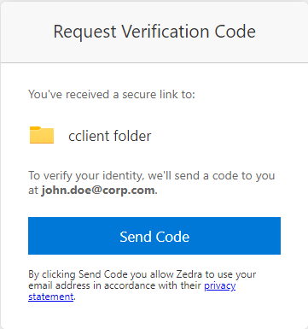:

1. Copy the **Authentication** **code** and then go back to the browser Window in which you opened the **External** **Collaboration** **Link**

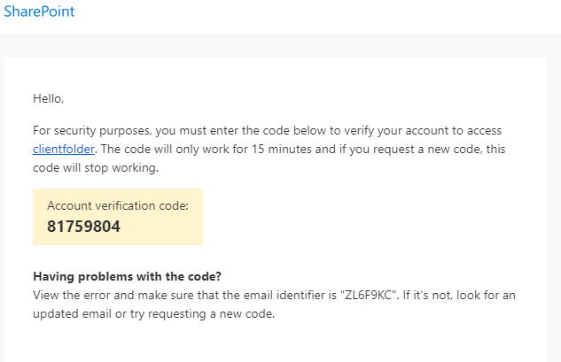

1. Enter the **Authentication** **code** mentioned above and click verify

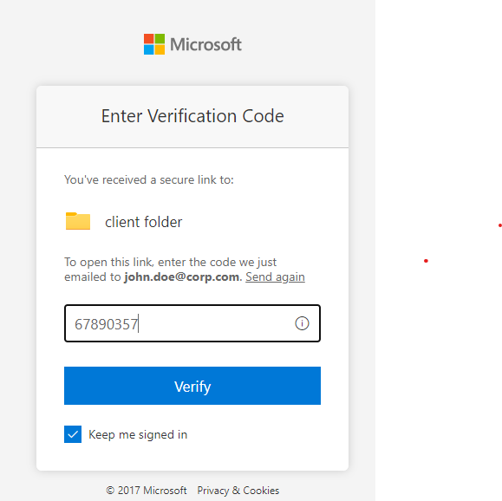

#### COLLABORATE

1. After you verify the **Authentication** **code**, you will be directed to the following window, which allows you to upload documents and entire folders or create folders so that you can customize the structure of the project.

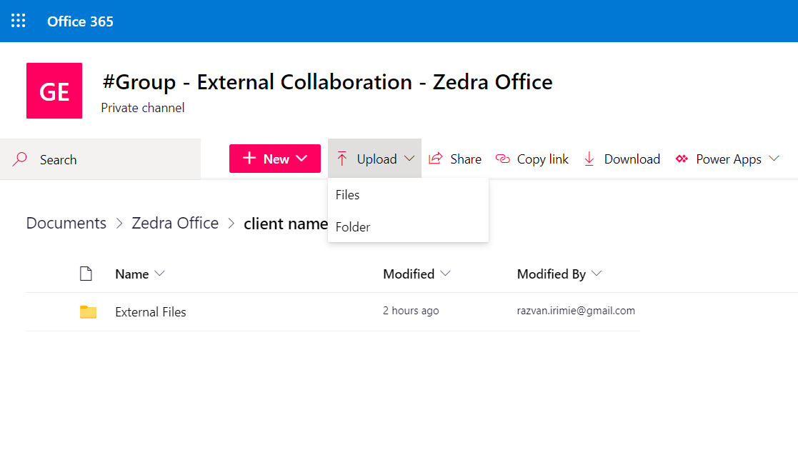Upload Files/folders:

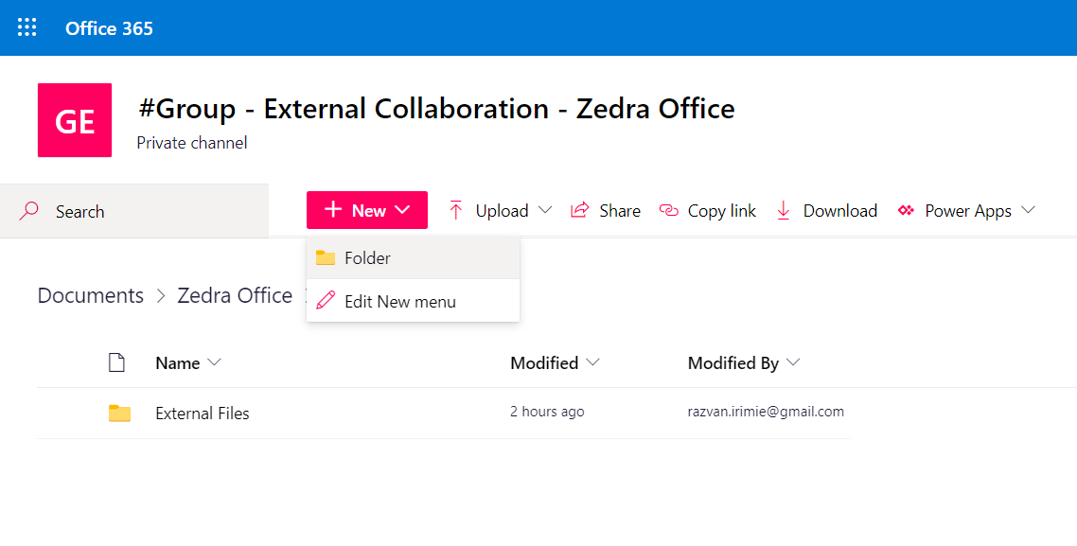  
Create Folders

1. Users can also upload files by “dragging” the files in the appropriate folder, from your machine:

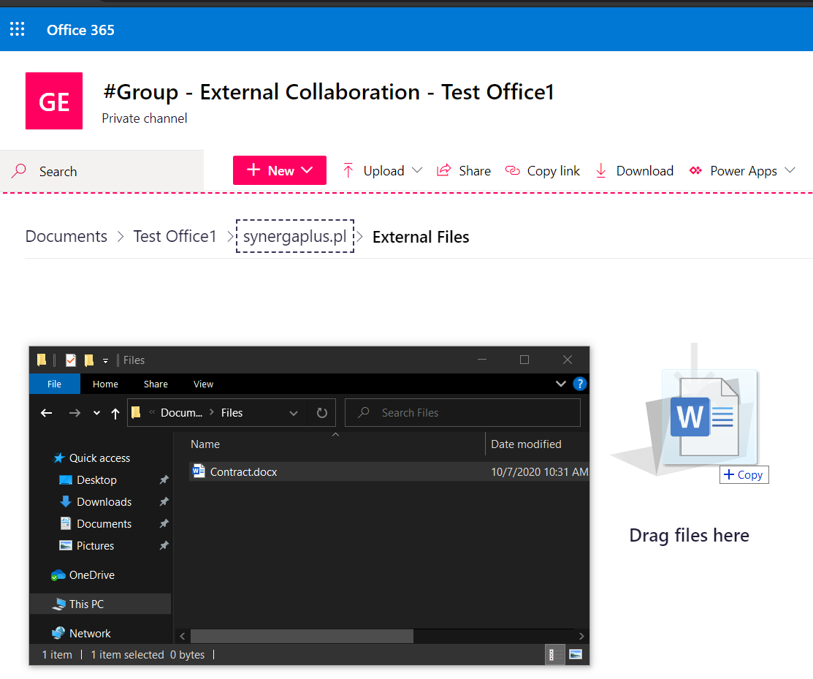

#### MANAGE CONTENT

Users have an extensive list of options when it comes to managing documents:

* In order to edit the document users can either:
  + Use the “Open in browser” option which will open the document in a new tab, in a Web Version of Microsoft Word.

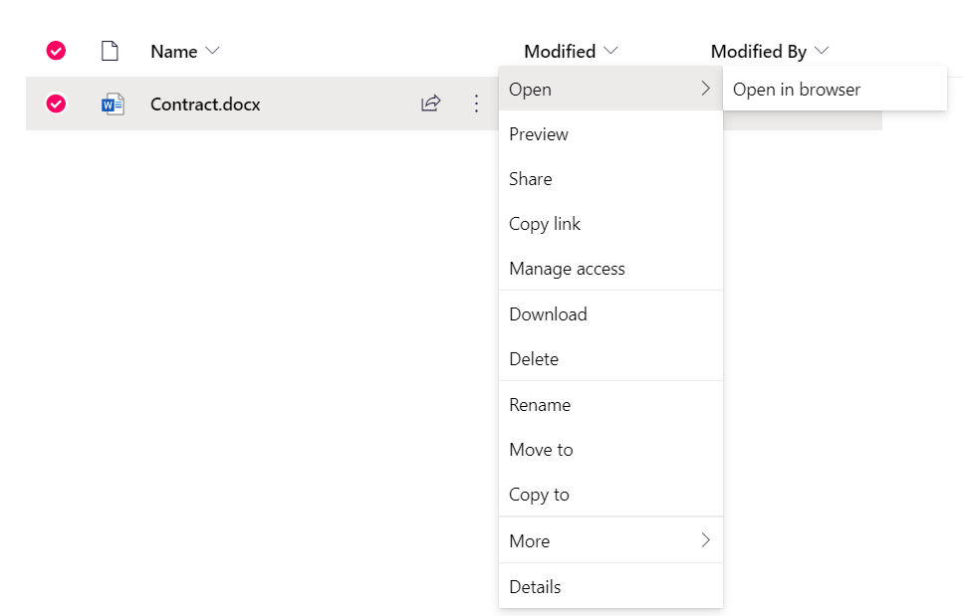

* + Download the document, edit it on their device and afterwards upload it back to the platform (see **section 3. Collaborate** for instructions on how to upload content).

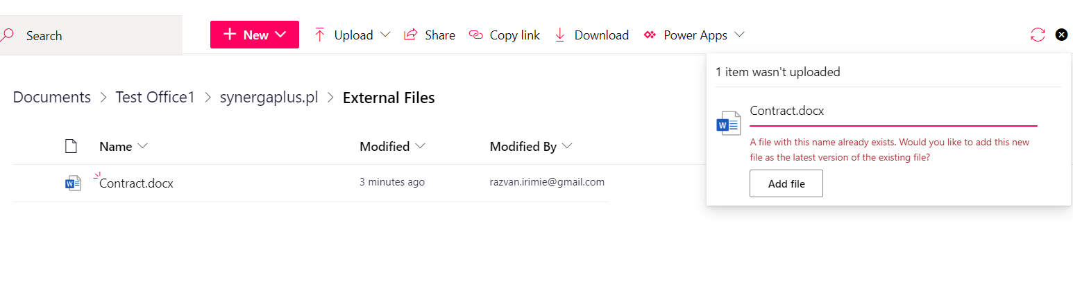

**!NOTE**: If the uploaded file has the same name as an already existing file on the platform users ill receive a prompt asking them to confirm if they would like to upload the file as a version of the existing file.

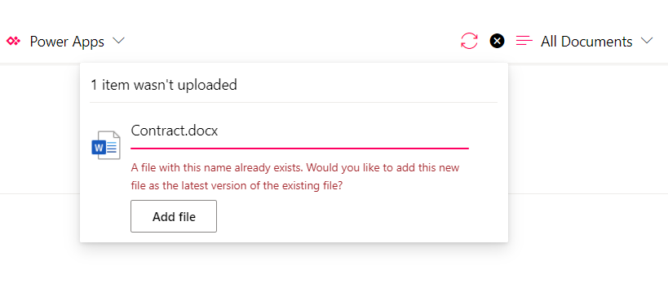

**For any further questions or inquiries please contact the Zedra Service Desk via email at** [**Servicedesk@zedra.com**](mailto:servicedesk@zedra.com?subject=External%20Collaboration%20Platform%20Assistance)